**Basic Shell scripting – define variables,shell features,read user input,conditions,loop,string and arthimetic operations**

1- Program to calculate the sum and product of 3 user defined values

2-Program that demonstrates the use of if..else with test. Find whether a number entered by the user is positive or negtive

3-Program for IF..ELSE without test. Calculate gross salary of an employee where gs=basic+hra+da, the basic salary is input from the user, hra is 10% of the basic and da is 37% of basic.

4- Program to check whether the file name entered by the user exists or not,

5 - Program for string comparison. Accept 2 strings from user and check whether they are identical or not.

6 - Program to check whether file has a permission to write

7 - Program to give grades using expr command. Accept 5 subject marks of a student and the name of the student. Calculate percentage and give appropriate grade to the student.

8 - Program to check whether the number is +ve or –ve usin elif

9 - Program to print the day of the week using case.. in

10 - Program to find the type of the character entered using case. The type could be a lower case character, an upper case character, a digit or a special symbol.

11 - Program to find the pattern using case. Check whether the given word begins with a vowel, ends with a vowel, begins with a digit, ends with a digit or is a 4 letter word.

12 - Program to find the type of the file

13 - Menu Driven Program

1 To see the contents of /etc/passwd

2 To see list of uers

3 To see present working directory

4 exit

14 - Program to print first n number and their sum: while loop

15 - Program to print first n numbers and their sum: do..until

16 - Program to illustrate the use of For Loop

17 – Program to find the factorial of a given number

18 – Program to find Fibonacci series upto the number N.

Eg: 0 1 1 2 3 5 8 13.....N

19 – Program to find whether a given word is a palindrome or not.

Note: A word is a palindrome when reversing the word produces the same original word.

Eg: MALAYALAM when reversed will result in the same word.

20 – Program to print the following pattern

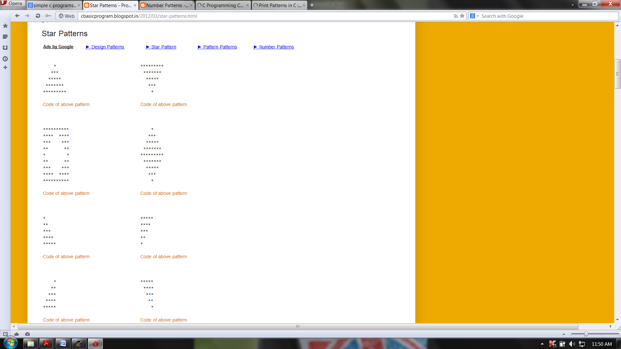

21 – Program to print the following pattern



22 – Program to print the following patterns



23 – Program to print the following patterns



24 – Program to print the following patterns



25 – Program to print the following pattern

12345

1234

123

12

1

26 – Program to print the following pattern

12345

2345

345

45

5

27 – Program to print the following pattern

54321

4321

321

21

1

28 – Program to print the following pattern

54321

5432

543

54

5

29 – Program to print the following pattern

1

12

123

1234

12345

30 – Program to print the following pattern

5

45

345

2345

12345

31 – Program to print the following pattern

1

22

333

4444

55555

32 – Program to print the following pattern

5

44

333

2222

11111

33 – Program to print the following pattern

55555

4444

333

22

1

34 – Program to print the following pattern

11111

2222

333

44

5

35 – Program to print the following pattern

11111

2222

333

22

1

36 – Program to find the sum of first N natural numbers.

37 – Program to find the following series.

Eg: 1! + 2! + 3! + 4! + ...... + N!